
What AI needs to know?

Static shedule
If there is a delay trying to match the next schedule
Data on each day, no. of passengers, occasion, stations popularity
Timely scheduling, platform allocation, cleaning schedules,
IDK what is Feeder transport services
Weather
Indian train complexity
Requires dynamic day to day data, a real-time data, operational parameters, live location, delay trends,

Uniqueness and Innovation

It handles more than 10,000 parameters.
It is able to assimilate and use real time data.
It shows me live location of train.
The UI is made simple and lightweight.
The web page is available in English, Tamil, Hindi, Telugu.
It handles congestion (or in simple words it tries to maintain the trains to not to collide or possibility of colliding).
It handles a maximum of a lakh people at the same time.
The UI is both available as webpage and app also.

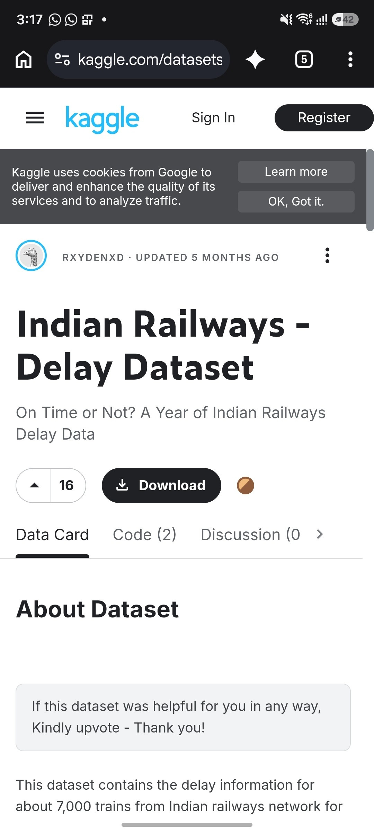
^
|
|
This dataset is just a dataset for simulation purpose or moreover you can say it is for test run
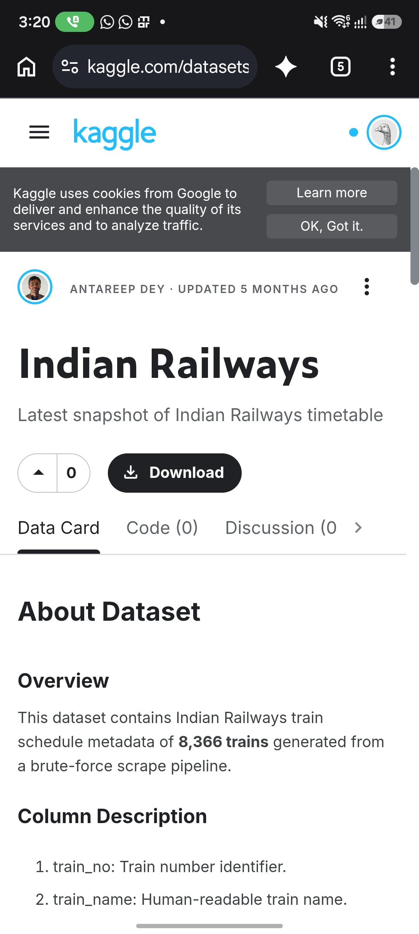
^
|
|
This dataset includes the details of all trains it's start, name, code, end, sub stops.

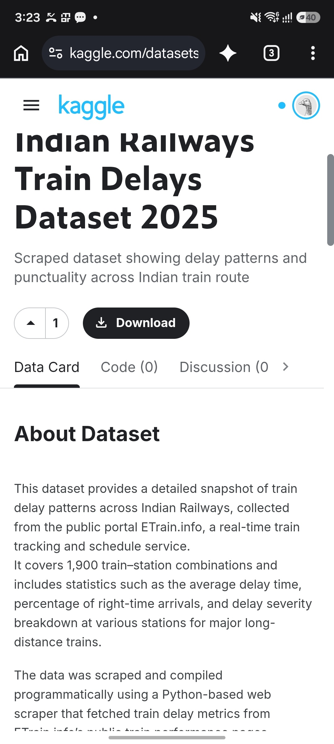
^
|
|
This dataset includes the delay of trains, but it needs to be checked or compared with the previous data

